**LEBANESE AMERICAN UNIVERSITY**

**USAID – HIGHER EDUCATION SCHOLARSHIP PROGRAM**

**HES - Volunteering Program Verification Form**

This form is to be used to document volunteering hours. If a student volunteers for multiple organizations, a separate form must be used for each organization. **This form must be turned in by the 28th of each month, the latest.**

I certify that the scholar Malak Khalil completed a total of 5 hours of service at InnovaThrive.

The hours were completed hours as per the below:

Hours # 5 (date) _2/12 – 6/12_ (initials of supervisor) __A.K.___

Hours # 0 (date) _9/12 – 13/12_ (initials of supervisor) __A.K.___

Hours # 0 date) _16/12 – 20/12 (initials of supervisor) __A.K.___

Hours # 0 date) _23/12 - 27/12 (initials of supervisor) __A.K.___

Brief description of the activities the scholar performed or participated in:

I conducted research on Artificial Intelligence in Sports Performance Analysis, focusing on how AI technology enhances athletic performance and efficiency.  
  
Key Applications:  
My study highlighted essential AI applications, such as performance tracking, injury prevention, and strategy optimization, which help teams and athletes gain a competitive edge.  
  
Real-Life Examples:  
I explored how major sports teams, like those in FIFA and the NBA, utilize AI-driven tools for player analysis, skill assessment, and strategic planning, showcasing AI’s practical impact on team success.  
  
Supporting Statistics:  
The research included insights into how AI-driven analytics contribute to significant improvements in athlete performance, often by providing data-driven strategies and coaching techniques.  
  
Advantages:  
AI in sports offers data-driven decision-making, allowing coaches and analysts to make more informed choices and refine training programs to boost performance and longevity.  
  
Disadvantages:  
However, implementing AI technologies in sports comes with high costs, requiring specialized tools, software, and expertise.  
  
Challenges:  
A major issue is ensuring data privacy and confidentiality for athletes, as sensitive performance and health data must be protected from unauthorized access and misuse.  
  
Future Research:  
Future research should focus on innovative applications of AI in sports science, exploring areas such as real-time analytics, biomechanics, AI-driven virtual coaching, and enhanced fan engagement through interactive technologies.

Written feedback about the scholar’s performance:

Malak demonstrated excellent research and analytical skills by exploring AI’s role in sports performance, showcasing innovative applications and practical examples for improvement.

Please rate the overall performance of the scholar at your organization:

|  |  |  |  |
| --- | --- | --- | --- |
|  | Mastery (5) | Proficient (3) | Emerging (1) |
| **Problem solver** | X |  |  |
| **Engaged & Committed** | X |  |  |
| **Open-minded & multicultural** | X |  |  |

Signature

& stamp

__________________________

_

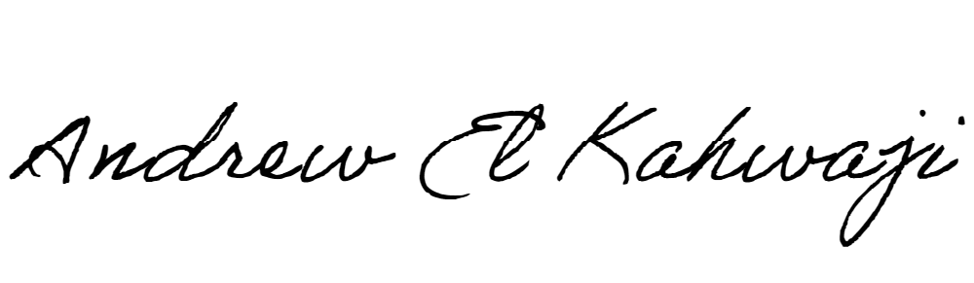

Printed Name _Andrew El Kahwaji_

Date __26/12/2024___

Email __andrew.lifesculptor.coo@gmail.com __

Phone __+961 71 914 378__